Fixed Drone Detection & Location With Automatic Jamming System

Model No: TTSKXM-J
- Overview
TTSKXM-J is a fixed detection system with comprehensive drone surveillance capabilities. It monitors the S/N code, model, coordinates (longitude, latitude, altitude), speed, home point, flight path, controller coordinates(longitude, latitude) and other information of drones within its range through data mining and deep analysis of drone signals.
TTSKXM-J is suitable for lower airspace security in scenarios such as governmental venues, critical industrial facilities, military compounds, airports, border control etc. It works independently offline, fits flexibly to various scenarios and supports quick installation. It also works together with multiple devices networked or integration with other counter drone devices such as TDOA system, jamming system and so on to form a more complete counter drone network.
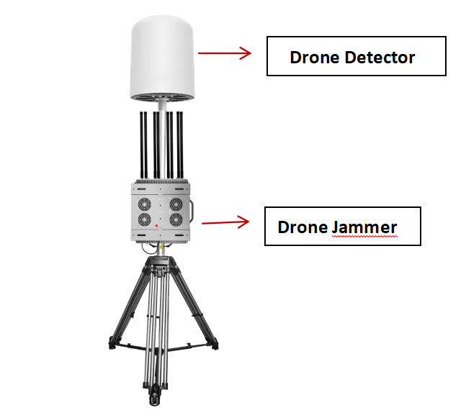
- Product pictures and composition
This product mainly consists of five parts: device host, Tripod, power Cable, Jammer device and bracket.
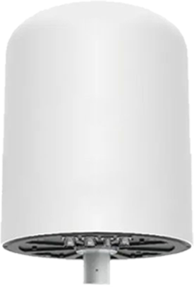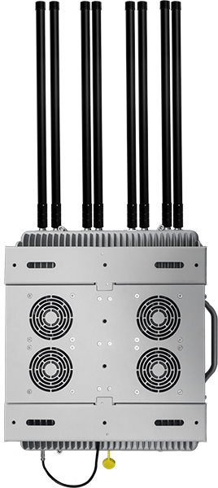

- Function Parameter
- Drone monitoring: Capable of obtaining information such as serial number, model, position (longitude, latitude, azimuth), speed, altitude, takeoff point, return point, trajectory, remote control position (longitude, latitude, azimuth), etc. of unmanned aerial vehicles within the monitoring range.
- Unique ID identification: Identify the unique serial number of the drone and confirm its unique identity information.
- UAV positioning: Positionable drone position information, real-time display of drone position (longitude and latitude), azimuth information, and distance information (the distance of the drone relative to the location of the device).
- Flying hand positioning: Positionable pilot position information, real-time display of pilot (remote control) position (longitude and latitude), azimuth information, distance information (the distance of the pilot relative to the position of the device).
- Multi target trajectory tracking: Capable of locating and tracking drone swarms, while displaying multiple drone flight trajectories.
- Black and White List: Distinguishable between cooperative and noncooperative drones, with no alarm provided by the device when detecting cooperative drones, and trust labeling for cooperative drones.
- Intrusion alarm: When the device detects a drone intrusion, it will issue an audible or visual alarm.
- Track playback: Support drone flight trajectory playback and assist security personnel in analyzing historical drone flight data.
- Detection record: The detection record list can preserve historical detection records, including multidimensional information such as drone serial number, model, frequency, etc.
- Data and information visualization analysis: Support UAV detection and flight data statistical analysis, which can be presented through thermal diagram, Line chart and other visual icons.
- Electronic map: Electronic map switching, including Gaode, Bing, Baidu, Google, etc.
- Multiunit network: The devices can be connected to the backend control platform through networking, and the multi unit network can meet the needs of large area coverage;
- Inspection and strike linkage: Capable of collaborating with countermeasures or deception devices to strike drones;
- Multiple device networking: The equipment can be networked with TDOA equipment to detect and locate drones, improving positioning accuracy and breadth.

- Product Features
- All detection models: The system can identify and detect common brands of drones such as DJI, AUTEL, Dahua, and Haoxiang, as well as the vast majority of models on the market such as self-made traversing machines and WiFi machines.
- Long detection distance: In an open environment, some models can detect distances of over 10km.
- Passive detection: The device does not emit any electromagnetic signals, has no electromagnetic environmental pollution, and is environmentally friendly.
- Comprehensive protection: The equipment operates continuously day and night throughout the day (7 * 24 hours), 24 hours a day (suitable for complex electromagnetic environments and harsh weather environments), and provides comprehensive (360° detection of drone intrusion) security in the core area.
- Fixed installation: The equipment adopts a fixed structural design, which can be installed and used outdoors for a long time.

- Product Index Parameters
- Performance index
Number | Index | Parameter | Notes
1 | Detection and identification of drone types | DJI series drones, FPVs, Xiaomi, Yuneec, Hubsan, Powervision, Tello drones etc.
2 | Localizable drone models | DJI mavic、air、mini、FPV、avata, etc.
3 | Detection frequency band | 100MHz--6000Hz
4 | Detection and positioning distance | 1~10km | Depending on the environment
5 | Detection height | 0m~1000m
6 | Number of targets that can be detected simultaneously | ≥5 sorties
7 | Capable of simultaneously tracking and displaying drone trajectories | ≥5strip
8 | Azimuth error | ≤1.5°（RMS）
9 | Positioning accuracy | ≤10m
10 | Detection success rate | ≥95%
11 | Identify response time | ≤5s
- Mechanical parameters
Number | Index | Parameter | Notes
1 | Detector Weight | ≤15kg | host
2 | Size | (H 56mm* Diameter 46mm)±2mm
- Electrical characteristics
Number | Index | Parameter | Notes
1 | Overall Power Consumption | ≤100W
2 | External power supply voltage | 100~220V AC
- Environmental adaptability
Number | Index | Parameter | Notes
1 | Operation temperature | -20~65℃
2 | Protection grade | IP65

- Safety standards
- Electromagnetic compatibility
The device meets the following EMC standards:
- GB/T 17626.2-2018 Electromagnetic compatibility test and measurement technology - Electrostatic discharge immunity test;
- GB/T 17626.3-2006 Electromagnetic compatibility test and measurement technology - Radio frequency electromagnetic field radiation immunity test;
- GB/T 17626.4-2018 Electromagnetic compatibility test and measurement technology - Electrical fast transient burst immunity test;
- GB/T 17626.5-2019 Electromagnetic compatibility test and measurement technology - surge (shock) immunity test;
- GB/T 17626.6-2017 Electromagnetic Compatibility test and measurement technology - Conducted Disturbance Immunity Test for Radio Frequency Field Induction;
- GB/T 17626.11-2008 Electromagnetic Compatibility test and measurement technology - Immunity Tests for Voltage Saggs, Short Interruptions and Voltage Changes;

All of the above tests are carried out according to Severity Level 3.

- Electrical safety
The equipment meets the following electrical safety-related standards:
GB 16796-2009 Safety Prevention Alarm Equipment - Safety Requirements and Experimental Methods.

- Environmental security
The electric field strength of the electromagnetic environment meets the requirements of the public exposure control limit in the GB 8702-2014 standard.

- Drone Detection & Location With Automatic Jamming System Introduction.
- Once the drone is detected, Click Counter UAV.
- Choose Drone frequency.
- Choose manual jamming or automatic jamming

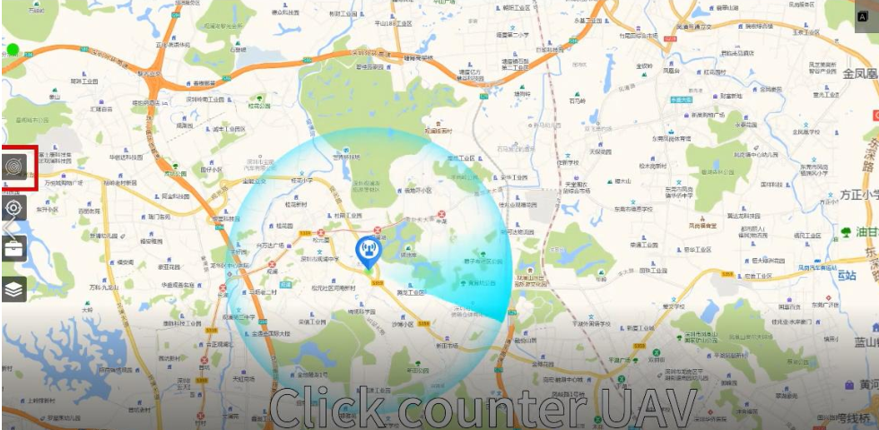
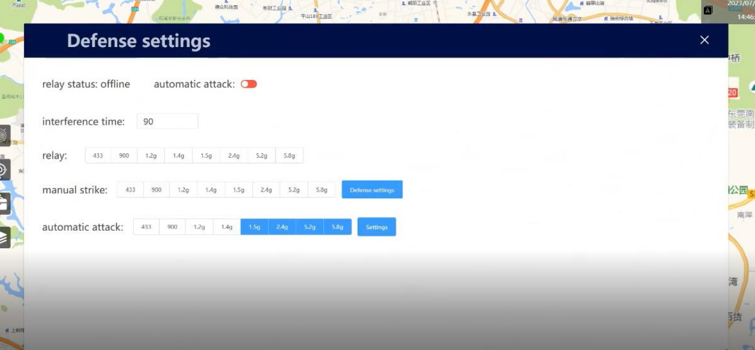

TTSKXM-J-OSJ is the ultimate outdoor anti-drone solution. It is safe, simple to operate and can be installed at houses, offices, airports or Military important places easily. The device uses focused electronic counter measures to block the drone’s control, GPS and video signals while minimizing the impact on other local devices. It comes with Omni directional antennas to disrupt 8 frequencies used by the majority of commercial drones. With a radius range of up to 3 km. With multiple power outputs the operator can choose if they want the drone to return to home or land. The device does no harm to the drone or its operator.

- Drone Jammer
- Technical Parameters
Channel | Working frequency |  | Output power(±1.5dBm)
5.8G | 5725-5850MHz |  | 47dBm （50W）
5.2G | 5150-5300MHz |  | 47dBm （50W）
2.4G | 2400-2500MHz |  | 50dBm （100W）
GPS L1 | 1550-1620MHz |  | 47dBm （50W）
1.4G | 1420-1530MHz |  | 47dBm （50W）
GPS L2 | 1170-1280MHz |  | 47dBm （50W）
FPV | 840-930MHz |  | 50dBm （100W）
FPV | 700-840MHz |  | 47dBm （50W）
433MHZ | 420-450MHz |  | 47dBm （50W）
Total 9 band, output power: 550W
Power Consumption : 1200W
Power supply: AC220V, DC24-28V
Main engine weight : 45Kg
Size: 513×462×233mm
With omni antenna 9pcs ,
Jammer Module Number : |  | 9
Cooling System: |  | Systematic Smart Cooling System
Jamming Source : |  | Noise Technology
Humidity: 30%-95%
Running temperature : -20℃ to +65℃
Omni Jamming range: 600m - 3km, according to signal density of mobile network

