Portable Integrated UAV Detection,
Jamming, and Spoofing Device

Model No: TTSKLB11
- Product Introduction
The backpack-style UAV countermeasure device integrates detection, jamming, and spoofing capabilities into a single unit, designed with both wearable and handheld portability. The device supports 360° omnidirectional detection and, with the aid of high-gain directional antennas, can precisely locate and direction-find certain DJI drones while effectively disrupting their links. The spoofing module not only repels drones but also allows the operator to flexibly choose the spoofing direction via directional keys, enabling more targeted and secure handling.
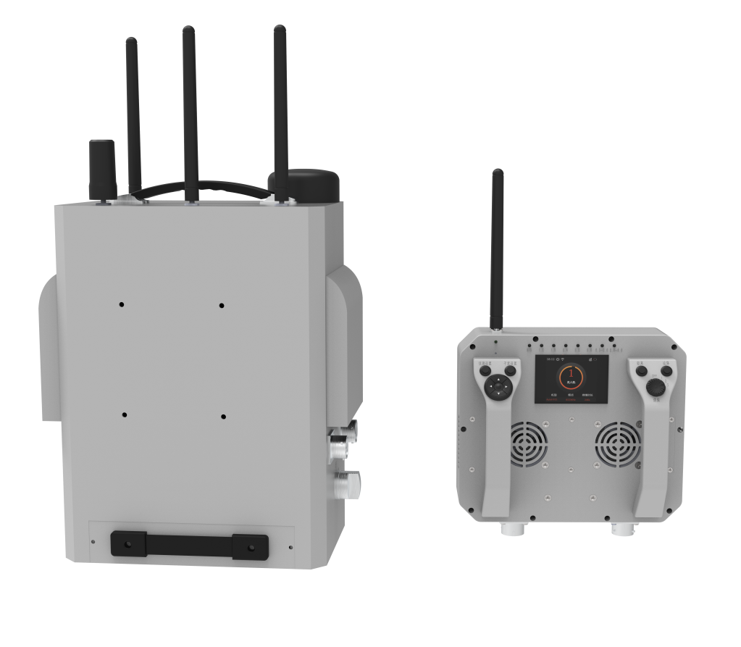
- Main Functions
- Detects UAV communication signals and triggers an alert upon anomaly detection.
- Capable of jamming UAV remote control links, image transmission links, and satellite navigation signals to meet various operational scenarios like repelling or forced landing.
- Supports spoofing functions that allow the operator to choose spoofing direction for flexible UAV control.
- Parses DJI drones using OcuSync2 and OcuSync3 protocols, accurately identifying model, frequency, and position.
- Equipped with an LCD screen that intuitively displays battery level, detection data, and device status.
- Automatically logs detection data and jamming status, exportable via data cable for further analysis.

- Product Specifications
- Detection Performance
Item | Specification
Detection Frequency | 300MHz–6GHz
Detection Range | ≥2 km (line-of-sight, low EMI environment)
Coverage | 360°
Direction Finding Accuracy | ≤20°
Alert Mode | Sound and light
Response Time | 3s
False Alarm Rate | ≤1 time/12h
- Jamming Performance
Item | Specification
Fixed Jamming Bands | 845–935MHz, 1160–1300MHz, 1550–1640MHz, 2.4–2.5GHz, 5.15–5.25GHz, 5.710–5.920GHz
Jamming Distance | ≥1 km (line-of-sight, 0.1W signal source, for DJI Mavic 3 with jamming ratio 2:1)
Response Time | ≤5s
- Navigation Spoofing Performance
Item | Specification
Working Frequency | GPS L1 / GLONASS R1 / BDS B1 / GALILEO E1
Effective Distance | ≥2 km
Response Time | ≤3s
Coverage | 360°
Spoofing Direction | Selectable

