Fixed TTSK-TDZ-2AB
UAV reconnaissance and decoy equipment
Technical Specifications

Product Model: | TTSK-TDZ-2AB
Version: | V1.0
date: | May 2025​​​

Table of contents
1. Introduction 3
2. Terms and abbreviations3
3. Equipment Overview 3
3.1 Device Name 3
3.2 Equipment Model 3
3.3 Equipment Purpose 4
3.4 Equipment technical parameters 4
4. Device Features and Functions 5
5. Equipment structure and components 6
5.1 Six views of the product 6
5.2 Product List 7
6. Device Control and Interface 8
6.1 Equipment Operation Interface 8
6.2 Equipment Security Protection 9
7. Equipment maintenance and care 9
8. After-sales service and support 9
9. Quality Assurance and Compliance 10
10. Appendix 10

1. Introduction
With the rapid development and widespread adoption of drone technology, drones have demonstrated tremendous potential in areas such as aerial photography, agriculture, rescue, and security. However, this also presents increasingly serious security risks. Frequent incidents of illegal intrusion, malicious reconnaissance, and privacy violations pose a serious threat to national security, public safety, and personal privacy. Therefore, the development of efficient and advanced drone countermeasures is urgently needed to maintain airspace security and safeguard social stability.

2. Terms and abbreviations
- Equipment : Fixed DR200- AB (C) UAV reconnaissance, strike and decoy equipment.
- Supplier : refers to the seller or manufacturer that provides equipment.
- User : refers to the individual or organization that purchases the equipment and uses it for related projects.

3. Equipment Overview
The fixed-mounted DR200- AB(C) drone detection, strike, and deception system consists of a drone detection system, a radio jamming system, and a navigation decoy system. It can detect, identify, jam, counter, and decoy drones , enabling them to hover, force a landing, or return, effectively protecting low-altitude airspace and preventing drones from entering the defense zone. It offers excellent detection and defense capabilities, operates at long distances, and can automatically detect and defend against drones without requiring human supervision.
Note: The deception function is optional and can be selected by the user as needed.

3.1 Device Name
Fixed TTSK-TDZ-2AB UAV reconnaissance and decoy equipment

3.2 Device Model

TTSK-TDZ-2AB

3.3 Equipment Purpose
The frequent occurrence of illegal intrusions, malicious reconnaissance, and privacy violations using drones poses a serious threat to national security, public safety, and personal privacy. Therefore, the development of efficient and portable drone countermeasures is urgently needed to maintain airspace security and safeguard social stability.

3.4 Equipment technical parameters

Serial number | Product Name | Performance indicators
 | Detection frequency band | 70MHz-6GHz full frequency band scanning, detection and display
 | Key detection frequency bands | 800MHz, 900MHz, 1.2GHz, 1.4GHz, 1.5GHz, 2.4GHz, 5.2GHz, 5.8GHz
 | Detection distance | ≥10km (depending on working conditions)
 | FPV image transmission detection | ≥ 1.5 km
 | Analog image transmission capture | Simulation video available
 | Detection range | Horizontal detection angle up to 360°  Vertical detection range: -90°～90°
 | Detection response time | The time required from powering on the drone to the device discovering and reporting the drone is ≤ 10s
 | Direction finding accuracy | ≤±3° (RMS, in the absence of obvious obstructions and electromagnetic interference)
 | Detection Display | Drone distance, flight altitude, speed, location (including latitude and longitude, and required to be accurate to 1 meter), aircraft model, aircraft SN, aircraft take-off point, aircraft return point, aircraft real-time trajectory, etc.
 | Interference distance | ≥3km (depending on working conditions)
 | Interference direction coverage | Horizontal detection angle up to 360°
 | Interference frequency band | Fixed frequency band:  700MHz~840MHz 50W  860MHz~930MHz 50W  1080MHz~1200MHz 50W  1200MHz~1340MHz 50W  1560MHz~1620MH 50W  2400MHz~2500MHz 100W  5100MHz~5300MHz 50W  5725MHz~5850MHz 100W
 | Interference response time | ≤7s
 | decoy signal | GPS, GLONASS, BeiDou
 | Decoy radius | 1~3km+ (depending on the environment and aircraft model)
 | Strategic Support | Directed expulsion, area denial, spatial deception, and space-time deception
 | Deception effective time | ≤4S
 | cloud platform | (1) It has unmanned and manual control functions, and can automatically complete the discovery, identification, warning, positioning, and disposal of drones. The software automatically starts the jamming device and automatically tracks and suppresses the drone according to the drone location information of the monitoring equipment;  (2) It has blacklist and whitelist functions;  (3) Equipped with high-definition GIS system functions: presenting information such as the surrounding environment and equipment deployment points;  (4) Log playback and statistical records: UAV intrusion log, log display angle, alarm time, frequency information, can replay UAV intrusion records, and provide UAV intrusion statistical reports;  (5) Positioning and automatic northing function: The system has GPS positioning function, which can mark the location on the map, and the system should be able to automatically calibrate the north;  (6) It has the function of extracting and adding drone signals: it can automatically collect unknown drone signals and extract parameters, and add them to the drone feature library through manual confirmation;  (7) Capable of displaying the device’s offline, standby, power-off, and abnormal status.  (8) It is capable of deceptively interfering with the satellite navigation coordinate information received by drones that use satellite navigation positioning, and has functions such as straight line mode and circle mode.
 | Interference host weight | ≤35kg
 | Interference host size | Length 465mm*Width 275mm*Height 510mm
 | Detection host weight | ≤15kg
 | Detection host size | Diameter 400mm*Height 370mm
 | Environmental adaptability | Operating temperature: -40℃~60℃

4. Device Features and Functionality
The fixed-mounted DR200- AB(C) drone reconnaissance, strike, and deception system consists of a drone detection system, a radio jamming system, and a navigation decoy system. It can detect, identify, jam, counter, and decoy drones, enabling them to hover, force a landing, or return, effectively protecting low-altitude airspace and preventing drones from entering the defense zone. It offers excellent detection and defense capabilities, operates at long distances, and can automatically detect and defend against drones without requiring human supervision .
Full frequency detection: 70MHz-6GHz full frequency detection, covering all models
High integration: It adopts a highly integrated design, integrating drone detection, interference and deception .
FPV super strong interference: effectively defend against RF flight control and FPV drones, with outstanding interference effect
Strong scalability: Expand and integrate radar, optoelectronics and other equipment, support single-machine operation and multi-device networking
Unmanned operation: It can realize automatic and intelligent execution of preset plans around the clock. When a drone is detected, it will quickly link and strike outside the defense zone.
Military quality: Full aviation aluminum body, no fear of high and low temperatures, strong environmental adaptability
Signal acquisition: It has built-in drone signal acquisition function, which can collect and learn unknown signals.
Customized service: Tailor-made intelligent solutions according to customer needs to provide customers with better defense effects

5. Equipment structure and components
The fixed DR200- AB (C) UAV reconnaissance, strike and deception equipment consists of a radio detection system, a radio jamming system, a navigation deception system, a control mainboard, a support rod assembly, a main body shell, a power supply assembly , etc.

5.1 Six views of the product
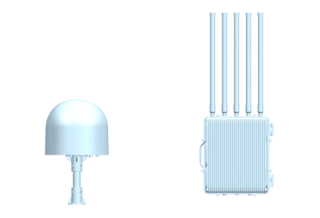 | 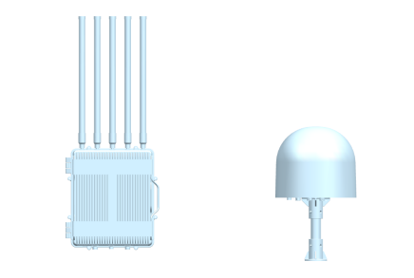
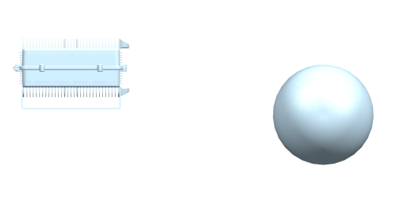 | 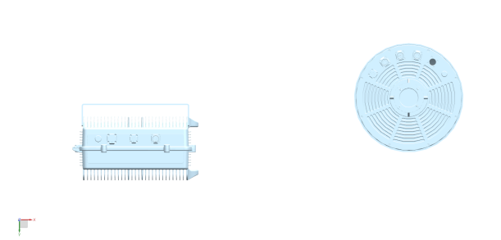
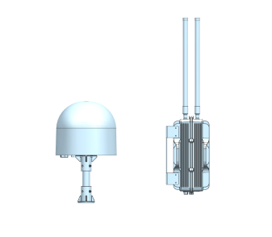 | 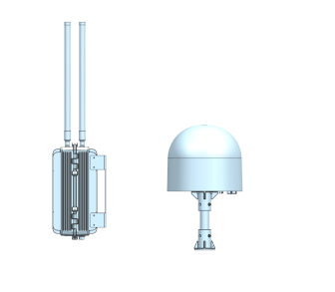

5.2 Product List
Serial number | product  name | Product images | quantity | Dimensions (mm) | Weight (kg)
1 | Detection  Host | 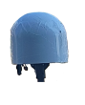 | 1 | Diameter 400*Height 370 | 13.5
2 | interference  Host | 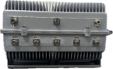 | 1 | Length 465*Width 275*Height 510 | 33kg
3 | interference  antenna | 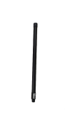 | 8 | Diameter 32*Height 600 | 0.45
4 | Detection host support rod | 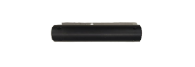 | 1 | Diameter 50*Height 500 | 0.45
5 | Cables | 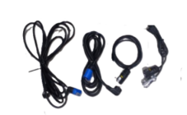 | 4 | / | 0.55
6 | Detection host aviation box | 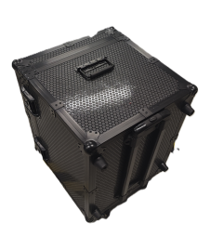 | 1 | 680mm×600mm×480mm | 15.05
7 | Interference with the host aviation box | 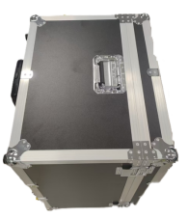 | 1 | 470mm*570mm*710mm | 13.75

- Device Control and Interface
Product interface definition :
Detection equipment power supply interface: 3-core power cord (AC220V 50Hz)
Detection equipment data interface: LAN (RJ45), WAN (RJ45), DATA (9-core)
Interference equipment power supply interface: 3-core power cord (AC220V 50Hz)
Interference equipment data interface: DATA (9-core)

6.1 Device Operation Interface
System platform display.
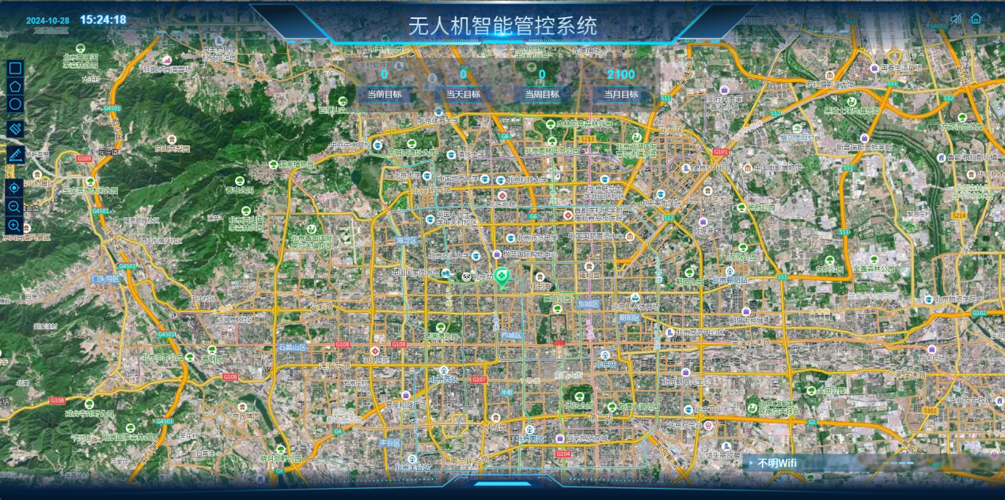

6.2 Equipment Security Protection
Flight case:
Countermeasure packaging size: 470mm*570mm*710mm
Detection packaging size: 680mm×600mm×480mm
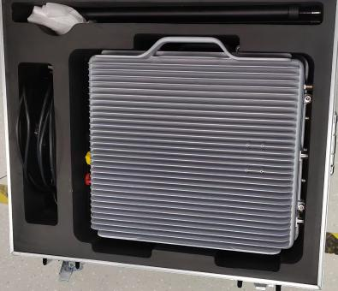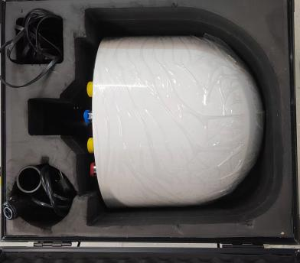

Equipment maintenance and care
Power on the device regularly to check its status.

After-sales service and support
Building A , Rongfeng Center, Longgang District, Shenzhen, Guangdong

Quality Assurance and Compliance
Provide product certificate.
ISO 9001 quality system certification.

appendix
This section provides additional information or attachments, such as technical data, certificates, reports, etc. of the equipment.
The above is the content of the equipment technical specification template. Based on the characteristics and requirements of the specific equipment, the above template can be modified and supplemented to meet actual needs.

