Handheld Integrated UAV Detection & Countermeasure Device

Model No: TTSKURA500
- Main Functions
- Integrated Detection and Countermeasure: Combines detection, direction finding, positioning, and jamming functions. Once the target UAV is detected and locked, countermeasures (repelling or forced landing) can be initiated immediately.
- UAV and Operator Positioning: Supports precise positioning of DJI UAVs and controllers using OcuSync2 and OcuSync3 communication protocols.
- Direction Finding: Supports detection and direction finding, displaying the UAV direction via compass.
- Intrusion Alert: Issues audible or sound-light alerts when a UAV intrusion is detected.
- UAV Identification: After entering detection mode, the system displays UAV model, frequency, and other information when a UAV is detected.
- Swappable Battery Design: Equipped with a removable battery design for quick replacement and extended operational time.

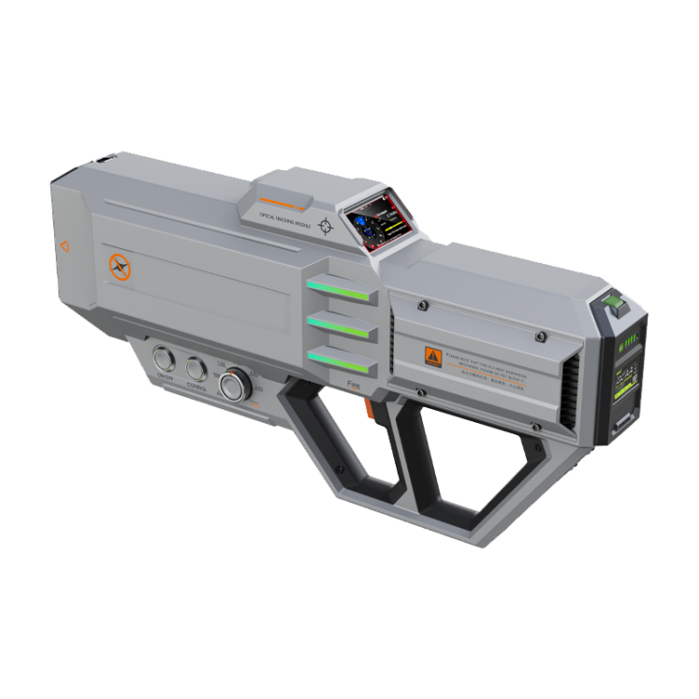
- Product Specifications
- Detection Performance
Item | Specification
Recognized UAV Models | DJI, Autel, ZLLRC, Yuneec, and FPV drones; expandable database
Locatable UAV Models | DJI drones with OcuSync2 (O2) and OcuSync3 (O3) protocols
Detection Frequency Bands | 433MHz, 845MHz, 915MHz, 1.2GHz, 1.4GHz, 2.4GHz, 5.2GHz, 5.8GHz
Detection Range | 500m – 1500m (affected by environment and UAV type)
Direction Finding Accuracy | ≤30° (RMS)
Positioning Accuracy | ≤10m

- Countermeasure Performance
Item | Specification
900MHz Band | 30W power amplifier
1.4GHz Band | 30W power amplifier
2.4GHz Band | 30W power amplifier
5.2GHz Band | 30W power amplifier
5.8GHz Band | 30W power amplifier
1.5GHz Band | 10W power amplifier
600MHz–6GHz Band | 20W power amplifier, software-adjustable
Jamming Range | 500m – 1500m (affected by environment)

- Mechanical Specifications
Item | Specification
Weight | 6 kg
Dimensions (L×W×H) | 685 mm × 298 mm × 110 mm

