UAV Detection System - Full Specification

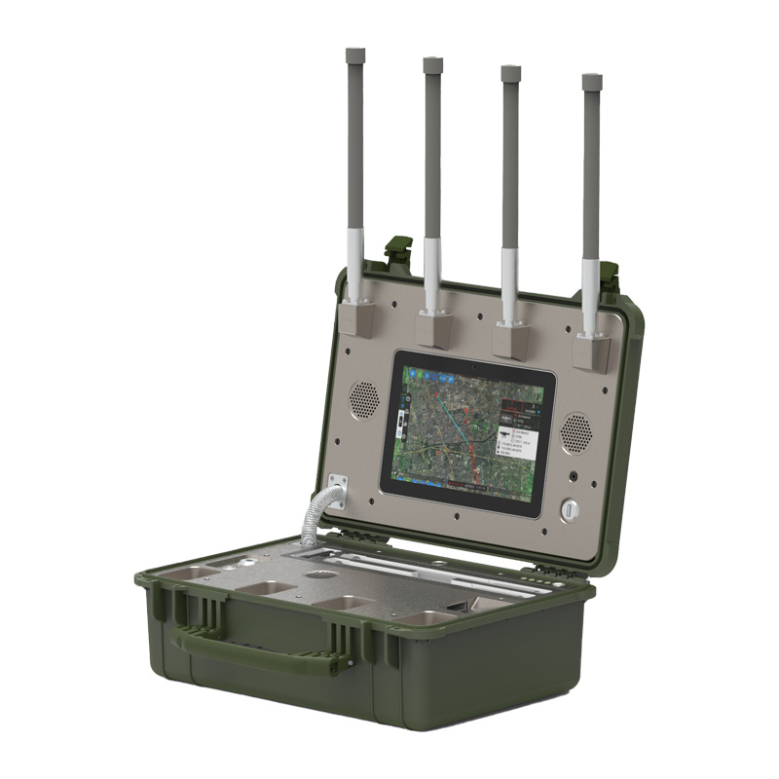
Model:TTSKC02

- Working Modes
Mode 1 (Aeroscope-like): Supports DJI, some Autel, Parrot, and Skylink drones. This mode provides detailed drone information, including model, route, latitude and longitude, altitude, and pilot location.
Mode 2 (CRPC Standard Software): Triggers an alarm when a drone enters the alert zone, without displaying detailed drone or pilot information.

- Functional Highlights
- Passive Detection: Receives signals without transmitting any electromagnetic signals, capable of detecting drone models and electronic fingerprints.
- Accurate Identification: Precisely identifies different UAVs even if they are of the same brand and model.
- Unattended Mode: Enables continuous 24/7 automatic detection and alerts.
- Whitelist and Blacklist: Allows one-click marking of drones; whitelist UAVs will not trigger alerts.
- Full Drone Library: Includes more than 350 drone models, supporting the full DJI series, mainstream brands, and DIY drones—covering over 98% of the UAVs on the market.
- System Integrability: Professional detection software can be integrated with radar, electro-optical systems, and jamming control systems.

- Technical Specifications
Item | Specification
Key Detection Frequency Bands | 900MHz / 1.4GHz / 2.4GHz / 5.2GHz / 5.8GHz
Detection Method | Passive (No signal transmission)
Detection Distance | Radius: 5 km, Coverage: 10 km
Operating Modes | Mode 1: Aeroscope-like; Mode 2: CRPC
Sensitivity | Better than -115 dBm (25kHz)
Directivity | 360° Omnidirectional
Supported Modulations | FM, 2FSK, 4FSK, GFSK, MSK, BPSK, QPSK, 16QAM, 64QAM, OFDM, DSSS, FHSS
Simultaneous Detection Capability | ≥30 drones
Detection Modes | Panoramic scanning, Channel scanning
Dynamic Range | 70 dB
Power Supply | Internal battery (15 hours) or AC 220V
Operating Time | 24/7 continuous or 15 hours on battery
Dimensions | 470 × 357 × 176 mm (cover closed)
Weight | ≤13 kg

