Handheld Drone
Detection and Positioning Equipment

Model No: LDSKL03
- Product Introduction
Based on CRPC 2.0 technology, it adopts a deeper data chain decoding solution to analyse and extract real-time flight attribute information from data in specific formats, and accurately identifies the drone’s graphic&video stream, SN number, geo-location, trajectory, altitude, speed and remote control position, etc., to detect, identify and locate the unauthorized drones more quickly and accurately. The device has an integrated design, small in size, light in weight, easy to carry, which is suitable for all kinds of low-altitude protection.

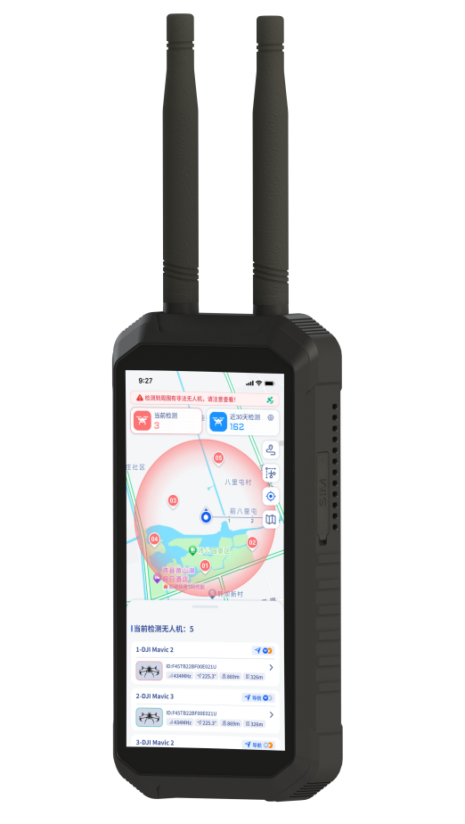

- Product Features
- Passive Detection：Passively receives only, does not emit any electromagnetic signals, no impact on the surrounding environment
- Precise Identification：Precisely identify the SN, model, geo-location, speed, altitude, trajectory, and remote controller information of the drones in real time
- Trajectory Tracking：Multi-target trajectory tracking, pilot (remote control) tracking
- Position Navigation：Detect the pilot’s (remote controller) position in real-time, one-click to track the pilot and the drone
- Black and White List：One-click to mark the black and white list, there will be no alarm for white-listed drones
- Network Management：Support network access to the control platform, to achieve multi-device collaboration, to achieve a wide range of prevention and control scenarios
- Wireless Intercom：Multi-device wireless network, instant communication, collaborative operations, to support the completion of command and planning work
- Graphic Steam：DIY graphic transmission traversing machine detection and identification, record the real-time graphic transmission screen of the drones;
- Compact and Portable：Light in weight and small in size; Portable, shockproof and drop-proof

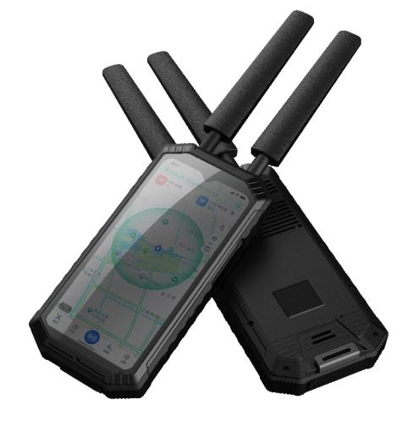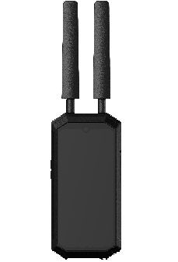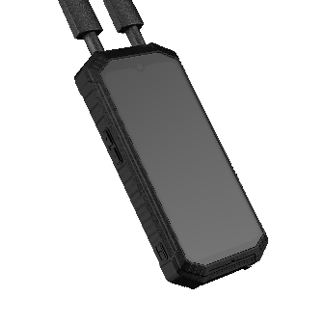

- Product Specifications
Working Principle | Passive detection, does not emit any electromagnetic signals
Detection Bands | 900MHz, 1.2MHz, 2.4GHz, 5.8GHz, WiFi；
Sensitivity | ≤-100dBm
Detection Distance | 0~3km+ (Different exist due to different environments and drone type)
Response Time | ≤5s
Detection Quantity | ≥10 Drones (Simultaneous)
Number of Drone Trajectories | ≥10 Drones (Simultaneous)
Position Accuracy | ≤3m (Available for the drones can be decoded)
Drone Library (Geo-Locaation) | DJI OC protocol models, Mavlink protocol, Parrot, TBS CrossFire and other brands
Dynamic Detection Movement Speed | ≥60km/h (Available for the drones can be decoded)
Screen Size | 6.0 Inch
Battery Capacity | 12000mAh
Endurance | 3～4h
External Interface | Type-C, SMA antenna connector (external screw and internal hole)*2, 3.5mm audio output connector*1, SIM card*1
Charging Power | DC9V, 2A
Charging Time | ≤3h（0%-100%）
Power Consumption | ≤15W
Size | 177mm * 89mm * 29.5mm（±2mm）
Weight | ≤580g(±0.05kg，without antenna)  ≤46g per antenna
Operation Temperature | -20℃ to +50℃
Storage Environment | 15～25℃  RH25～65%
IP Level | IP54

- Product View
