Backpack Drone Detector& Jamming Integration

Model No.: TTSKBPDJ

- Overview

TTSKBPDJ is a portable jamming detection system with comprehensive drone monitoring capabilities. It monitors the model and operating frequency of drones within the range through data mining and in-depth analysis of drone signals, and performs signal jamming on its own.

Product pictures and composition
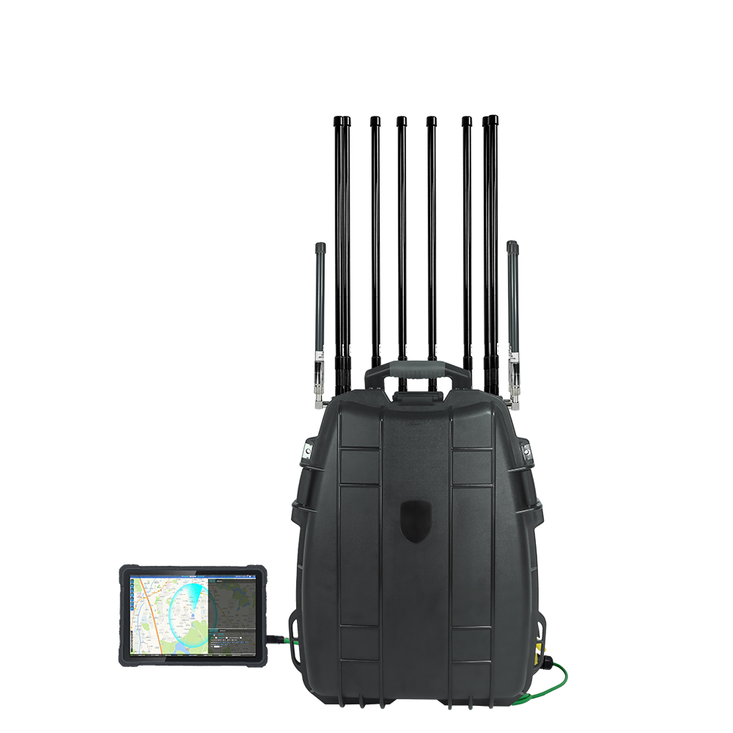

Table 1 Product Hardware Composition Details
Serial Number | Device Name | Number | Unit
1 | Device host | 1 | pc
2 | RF antenna | 10 | pcs
3 | GPS antenna | 1 | pc
4 | power adapter | 1 | pc

Table 2 Product performance indicators-direction finding mode
NO. | Item | Technical parameter
1 | Work pattern | Passive detection
2 | Work frequency | 400M, 900M,1.2G,2.4G, 5.2G,5.8G and other commonly used drone frequency
3 | Detection and identify UAV type | DJI series, FPV, FEMI, YUNEEC, AUTEL, HUBSAN, Powervision, Tello UAV and video transmission module
4 | Detection range | 100-2000m (urban environment, tested by DJI AIR2 target)
5 | Probe azimuth | 0 °~360° (omnidirectional antenna)
6 | Recognition time | ≤2s
7 | False alarm rate | 1 time / day
8 | Capacity of discernment | The number of drones that can be simultaneously detected and identified ≥ 10 (5 manufacturers)

No. | ITEM | Technical parameter
1 | Work pattern | Directional passive detection
2 | The object of action | DJI (Phanton and Mavic), AUTEL, and HUBSAN
3 | Work  frequency | 2.4G,5.8G
4 | Detection range | 100-2000 m (urban environment with DJI AIR2)
5 | Probe azimuth | ≤30° (UAV does not change the frequency during the locked DF mode and is 1 km from the device)

Table 3 Product performance Jamming mode
Channel | Working frequency |  | Output power(±1dBm)
CH1 | 420-450MHz |  | 47 dBm(50W)
CH2 | 700-840MHz |  | 47 dBm(50W)
CH3 | 840-930MHz |  | 47 dBm(50W)
CH4 | 1550-1610MHz |  | 47 dBm(50W)
CH5 | 1100-1300MHz |  | 47 dBm(50W)
CH6 | 5150-5300MHz |  | 45 dBm(30W)
CH7 | 2400-2500MHz |  | 47 dBm(50W)
CH8 | 5700-5900MHz |  | 47 dBm(50W)
Total output power: 380W
Power consumption : 900W
Power supply: AC90-260V, DC24-28V
Main engine weight : 12Kg (Manpack 10KG,Antenna 1.5KG,Control Box 0.3KG)
Size:520*400*230mm
With omni antenna 8 pcs
Jammer Module Number :8
Cooling System: |  | Systematic Smart Cooling System
Jamming Source : |  | Noise Technology
Humidity: 30%-95%
Running temperature : -20℃ to +60℃
Inside battery working 1.5h: 24V,25AH
Battery charger: 5A(Open the external switch to charge, automatically manage the charging current, full automatically disconnect)
Jamming Range: 800-1500m
External Remote control Panel : shows the battery voltage, can switch on/off each band.

