Backpack Drone Suppression Device

Model No: TTSKB10
- Product Introduction
This product complies with the design requirements concerning environmental protection and personal safety. Storage, use, and disposal of the product shall be carried out in accordance with the product manual, relevant contracts, or applicable national laws and regulations.
This manual introduces the features, technical parameters, and operation instructions of the backpack drone countermeasure device.
The use of this device may be restricted by local laws and regulations. Please ensure compliance before using the product.

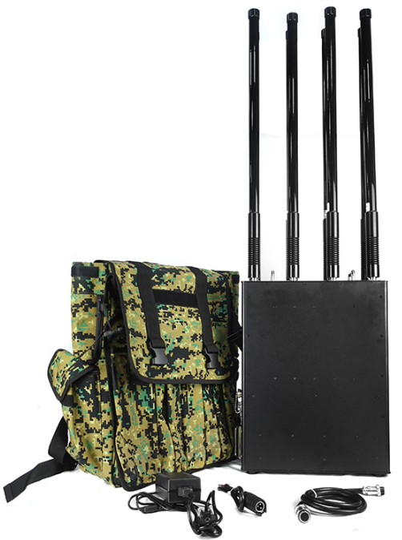

- Product Description
This device is mainly used for drone countermeasures, driving drones away or forcing them to land within visible range. It adopts a backpack design with built-in battery for long-time portable use. Frequency bands, power, color, and appearance can be customized according to customer needs.
It is especially suitable for large venues, anti-terrorism units, and checkpoints.

- Product Features
- Multi-channel jamming;
- Soft start circuit design avoids ignition caused by mechanical switches, high integration and stable operation;
- Equipped with omnidirectional and directional antennas to meet various application needs;
- Backpack design for flexible deployment, ideal for emergency, mobile, and temporary control scenarios;
- Built-in rechargeable battery with 40–60 min usage after full charge;
- Military-grade housing, impact-resistant and durable;
- Power supply: internal battery or DC24V external power; equipped with efficient cooling fan and heat sink to ensure stable operation and long service life;
- Adjustable by module; each band can be turned on/off independently. High-gain omnidirectional fiberglass antenna ensures optimal range; different antennas can be selected based on environment.

- Key Specifications
- Jamming Parameters
Band | Power Output
Band 1 | 430–440MHz, 50W / 47+1dBm
Band 2 | 855–935MHz, 50W / 47+1dBm
Band 3 | 1150–1300MHz, 50W / 47+1dBm
Band 4 | 1370–1450MHz, 50W / 47+1dBm
Band 5 | 1550–1636MHz, 50W / 47+1dBm
Band 6 | 2400–2500MHz, 50W / 47+1dBm
Band 7 | 5135–5350MHz, 50W / 47+1dBm

Frequency band and power can be customized upon request

- Structural Parameters
Item | Specification
Backpack size | 350×160×440mm
Total weight | 23.8kg
Battery size | 265×115×80mm
Battery weight | 4.15kg
Battery life | 40–60min
Charging mode | 29.4V charging adapter

- Product List
No. | Name | Unit | Qty | Remarks
1 | Host (battery included) | set | 1 | 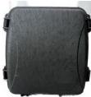
2 | Omnidirectional antenna | strip | 8 | 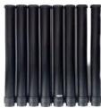
3 | Directional antenna | set | 1 | 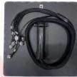
4 | Handle | set | 1 | 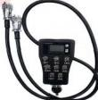
5 | Charger | set | 1 | 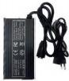
6 | External power cord | strip | 1 | 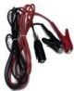
7 | Instructions | piece | 1
8 | Packing Box | piece | 1

- Operating Instructions
Note: Before powering on, please ensure the battery is sufficiently charged and all antennas are properly installed.

- Check whether the appearance of the device is intact. Refer to the product list to verify all accessories are included.
- Match the identifiers on the omnidirectional or directional antennas to the antenna ports on the device, and then tighten them securely.
- Connect the control handle to the main unit.
- Device startup:
- Method 1: Turn the main switch to the right to select the built-in battery mode, and wait about 5 seconds for startup.
- Method 2: Connect the external power cable to the DC24V input port, turn the switch to the left for external power mode, and wait 5 seconds.
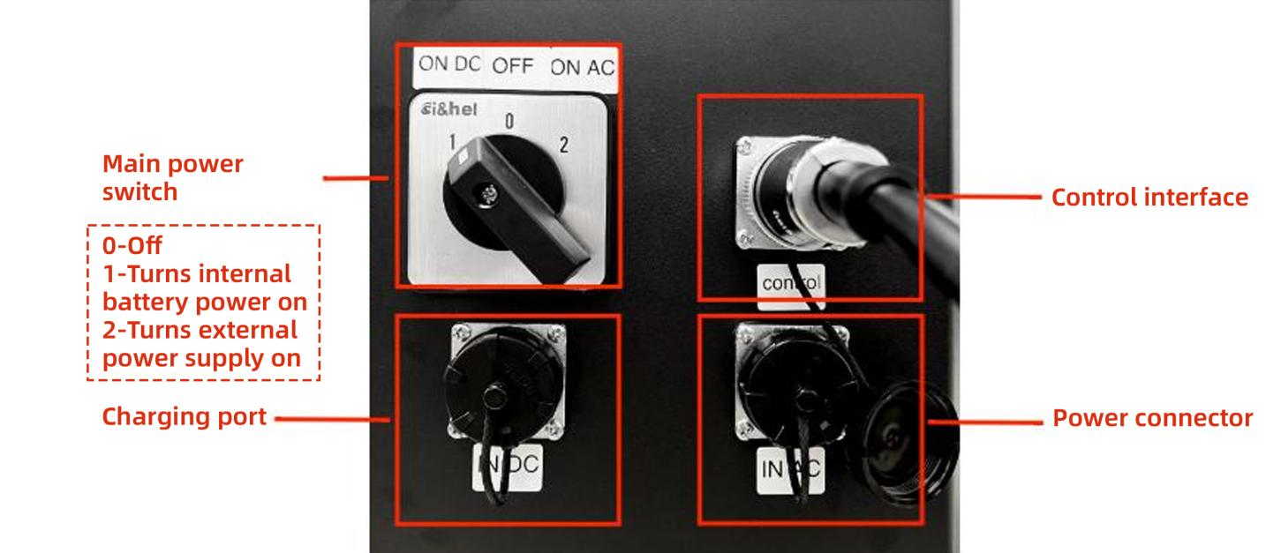
- The battery level display screen shows the current battery level.
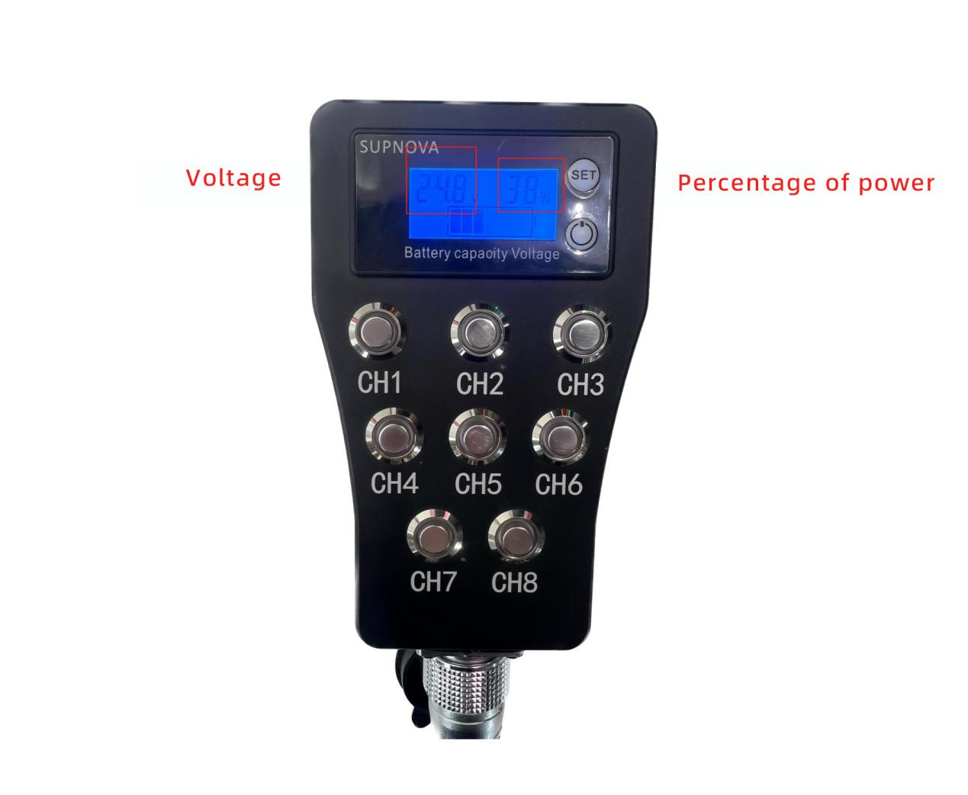
- Start/stop jamming: Press the channel selection buttons (CH1–CH8); indicator lights mean active. Jamming starts after 30 seconds. Press again to stop.

